Horizontally-Split Casing Joint Design

Background
For more than 100 years, Dresser-Rand has been a world leader in energy conversion technology, designing, manufacturing, and servicing a wide range of field-proven centrifugal and reciprocating compressors, gas and steam turbines, expanders, rotating separators, and control systems. Since the mid-1900s, we have built centrifugal compressors for a variety of applications in the oil & gas and petro- chemical industries. Compressor casings come in two different styles: barrel or radially-split and horizontally split. Horizontally split casings are typically bolted together and, therefore, used for lower pressure applications. However, there has been increasing demand for horizontally split casings capable of containing higher pressure applications. The difficulty is developing a joint design for the horizontal split that will remain sealed at high pressure.
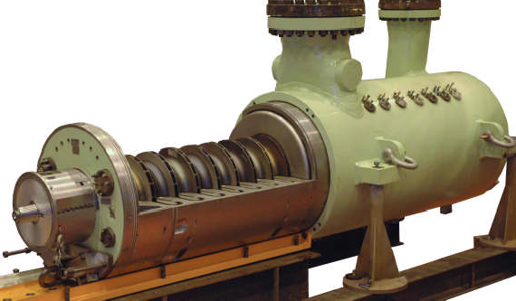
Figure 1: Barrel (or radially-split) compressor casing

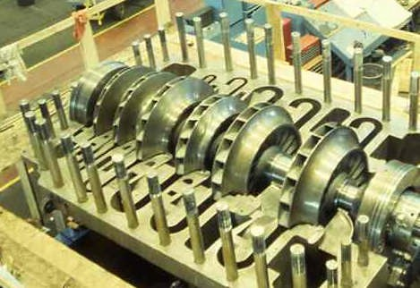
Figure 2: Horizontally-split compressor casing
(Note bolts for holding casing together)

Project Objective
The objective of this project is to develop a joint design for a large, horizontally-split compressor casing that will remain sealed and maintain its structural integrity at a pressure of 1500 psi. The casing ID for the casing is 60” (1524mm). The team is expected to use Finite Element Analyses to demonstrate the effectiveness of their joint design. If time allows, a prototype of the horizontal split design should be built to illustrate the assembly method, etc.

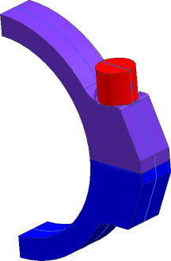
Figure 3:Schematic of bolted joint

Deliverables
The deliverables from the project include a final report detailing the results of the investigation, drawings / schematics of the proposed joint design, analysis results confirming the effectiveness of the proposed design and, if completed, a proto-type of the impeller showing the recommended joint design, bolting pattern, etc.

Expectation of the Team
Team membership will include engineering majors. Team members are also encouraged to accept summer employment at D-R’s Olean NY facility to continue with the solution development.

Contact Information:
Contact Name
Phone
Email

